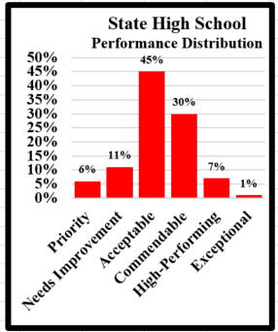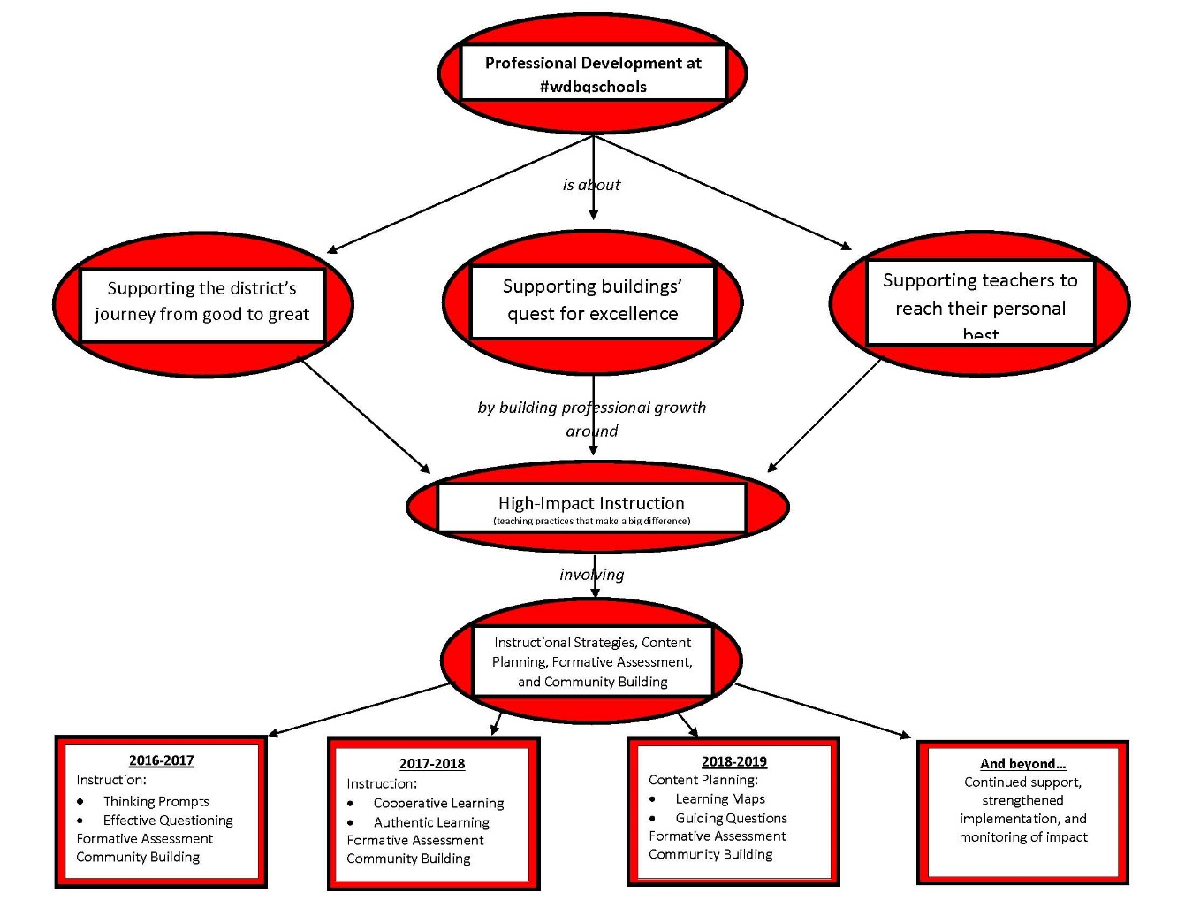

**Tardies**

Total number of tardies the

week of:

**Feb 13-Feb 17**

187

965

49.1%

**STATE**

**ACTION PLAN**

**Current School Rank**

**ACCEPTABLE**

64.7 pts.

100 pts.

SCORECARD

**WESTERN DUBUQUE**

**HIGH SCHOOL**

**STATE**

53.2%

**WDHS**

32.1%

**WDHS**

82.7%

**WDHS**

50%

**STATE**

**WDHS**

**WDHS**

41.7%

**STATE**

39.8%

**STATE**

25.5%

**College & Career Growth**

“Percent of students that are growing each year toward college & career ready”

**Proficiency**

“A schools success at meeting performance level benchmarks”

**Attendance**

Total number absences the week of:

**Feb 13-Feb 17**

**Annual Expected**

**Growth**

“Percent of students achieving a year of academic growth in a year’s time”

**Graduation Rate**

“Percent of students that are completing high school in five years”

**College & Career Ready**

“Percent of students that are at or above college readiness benchmarks”

**Closing the gap**

“Is progress being made in closing the achievement gaps for FRL (Free & Reduced Lunch), IEP (Individualized Education Plan), ELL (English Language Learner)”.

46.8%

79.0%

**STATE**

92.7%

**WDHS**

99.5%